AI ASSISTED CODING

Assignment-3:

**2403A52107**

**Pavani Voddepalli**

**Batch : 24BTCAIAI05**

## **TASK-1:** Write a Python Code to calculate the compound interest using functions dynamically .

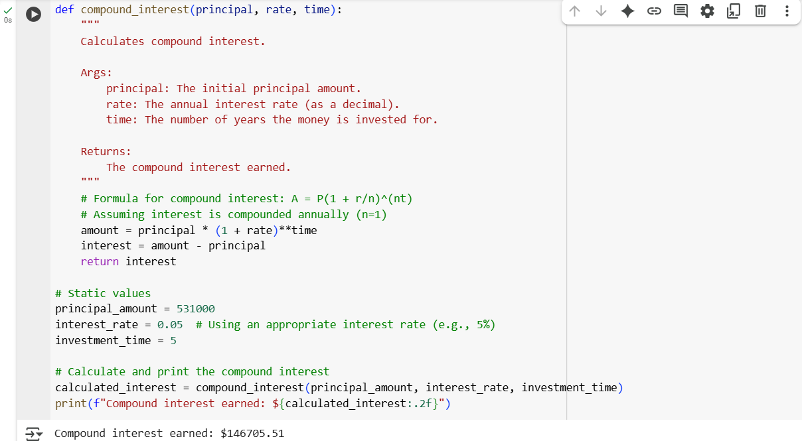

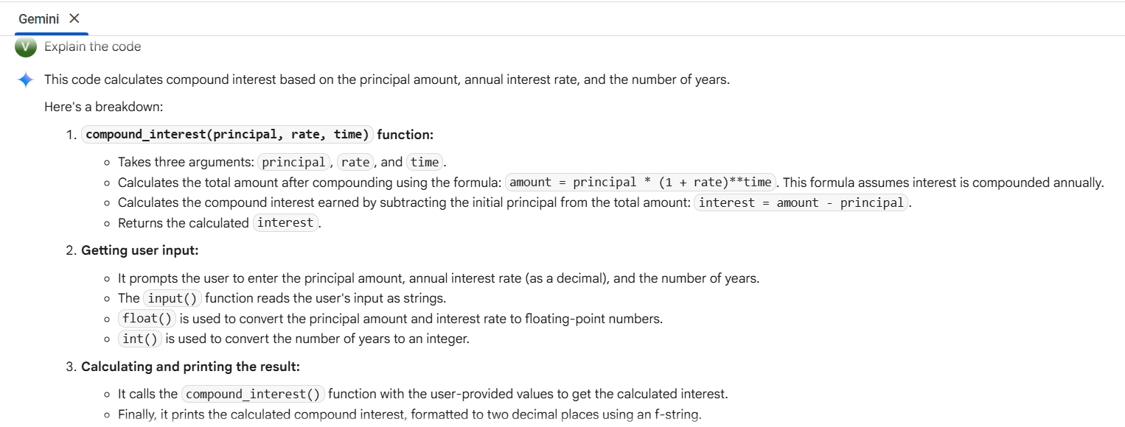

## **TASK-2:** Write a python code using functions to calculate average, median, and mode of a list of numbers

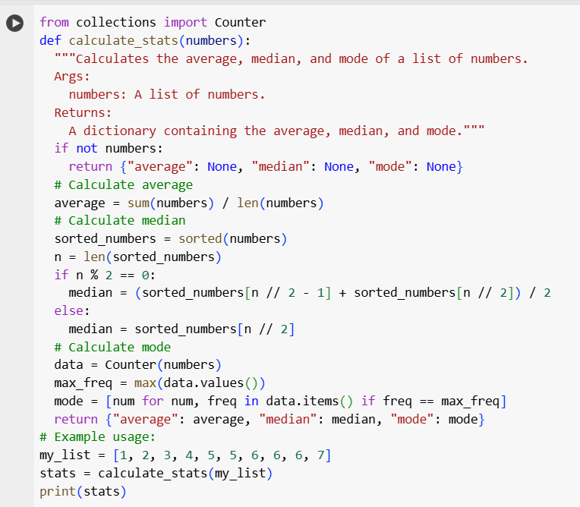



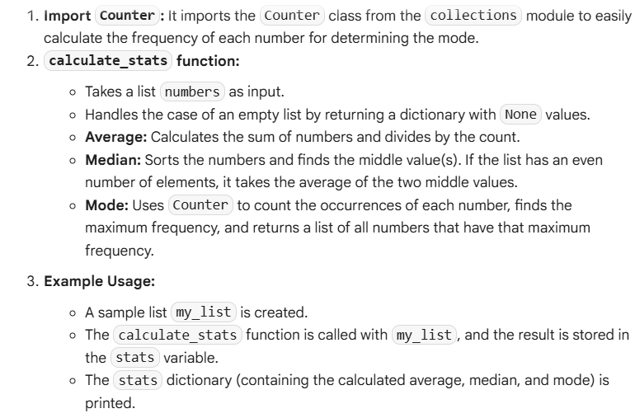

## **TASK-3:** Write a python code to convert any numbers to binary using functions

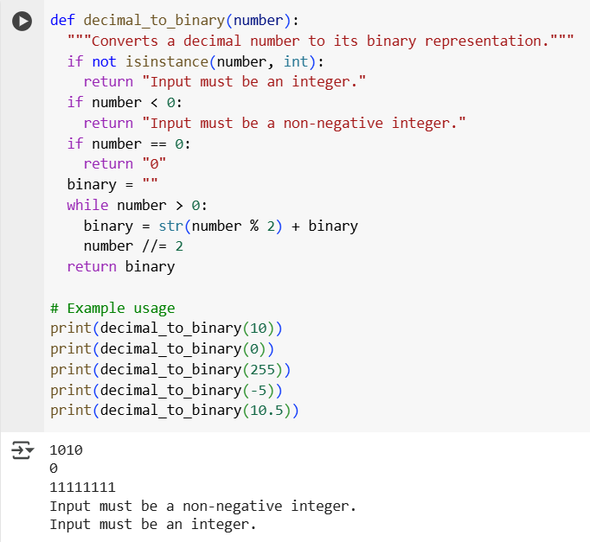

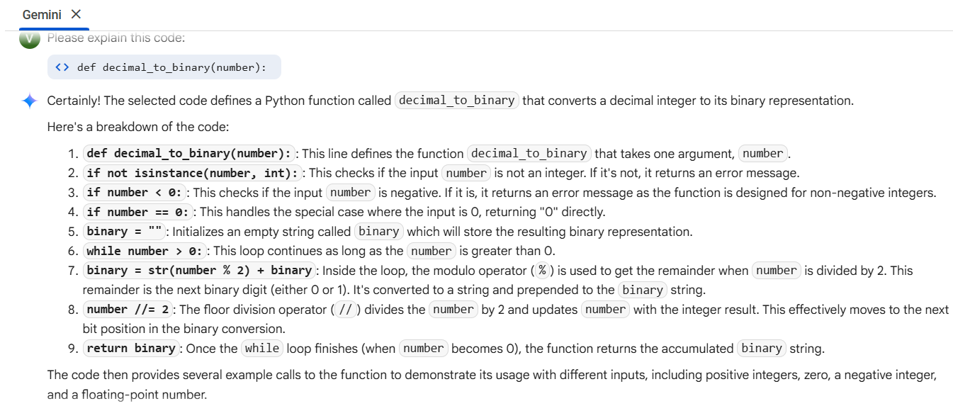

## **TASK-4:** Create an user interface for an hotel to generate bill based on customer requirements

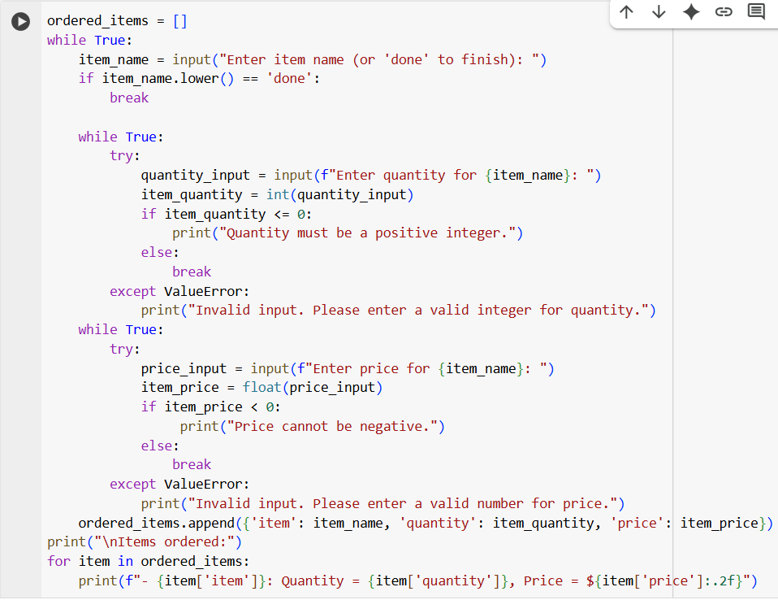

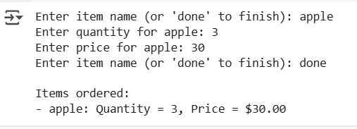

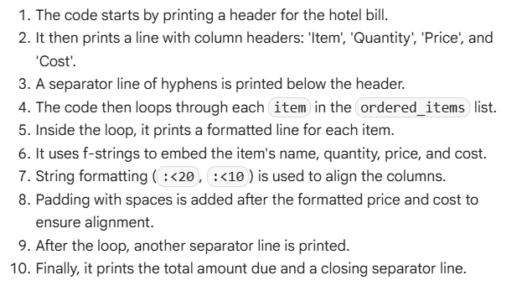

TASK-5 : Write a Python function that converts temperatures between Celsius and Fahrenheit.

